Было произведено подключение к PostgreSQL через psql -U postgres. Создана база данных transport командой CREATE DATABASE transport;. И было выполнено подключение к базе выполнено командой \c transport;.

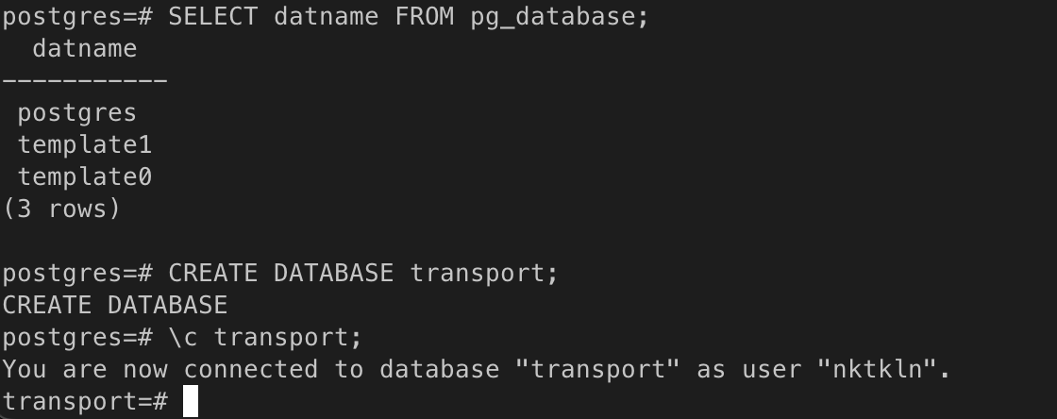
На скриншотах ниже показано создание всех таблиц в базе данных transport:

CREATE TABLE IF NOT EXISTS type (
type_id SERIAL PRIMARY KEY,
type_name CHARACTER VARYING
);

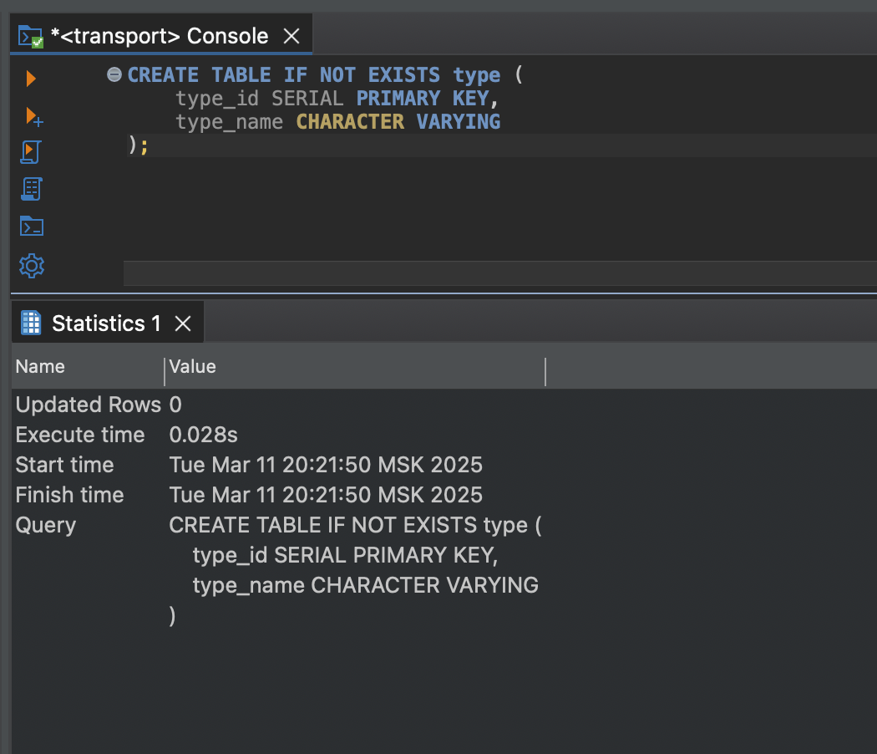

CREATE TABLE IF NOT EXISTS districts (
district_id SERIAL PRIMARY KEY,
district_name CHARACTER VARYING
);

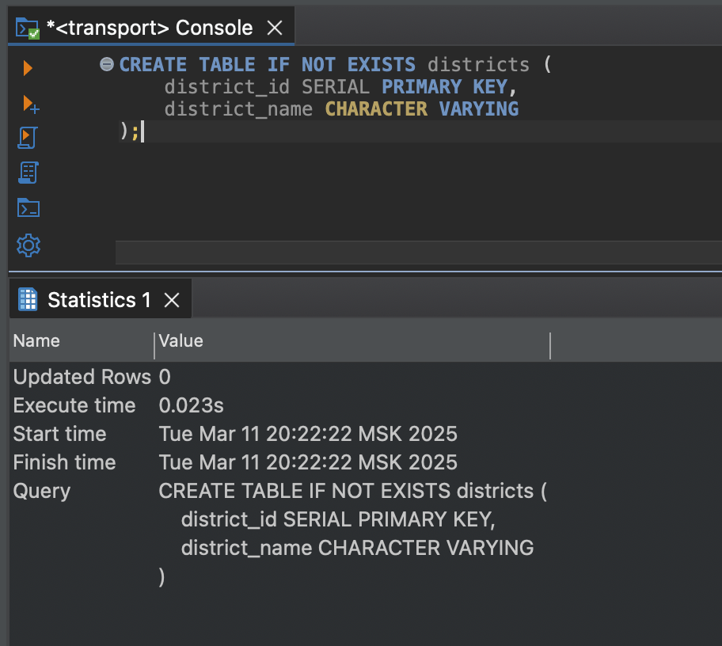

CREATE TABLE IF NOT EXISTS building_materials (
material_id SERIAL PRIMARY KEY,
material_name CHARACTER VARYING
);

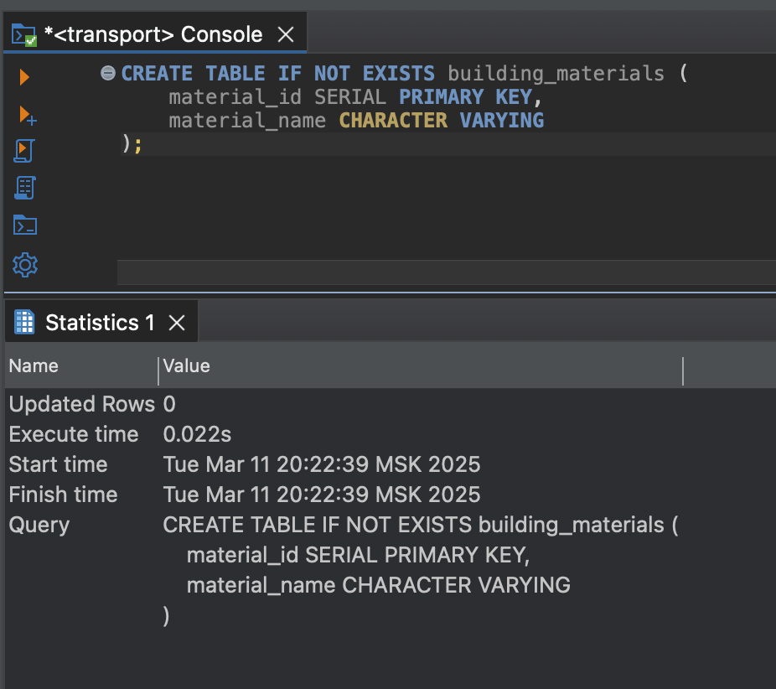

CREATE TABLE IF NOT EXISTS real_estate (
estate_id SERIAL PRIMARY KEY,
district_id INT,
address CHARACTER VARYING,
floor INT,
rooms INT,
type_id INT,
status INT,
price INT,
description TEXT,
material_id INT,
area INT,
announcement_date TIMESTAMP
);

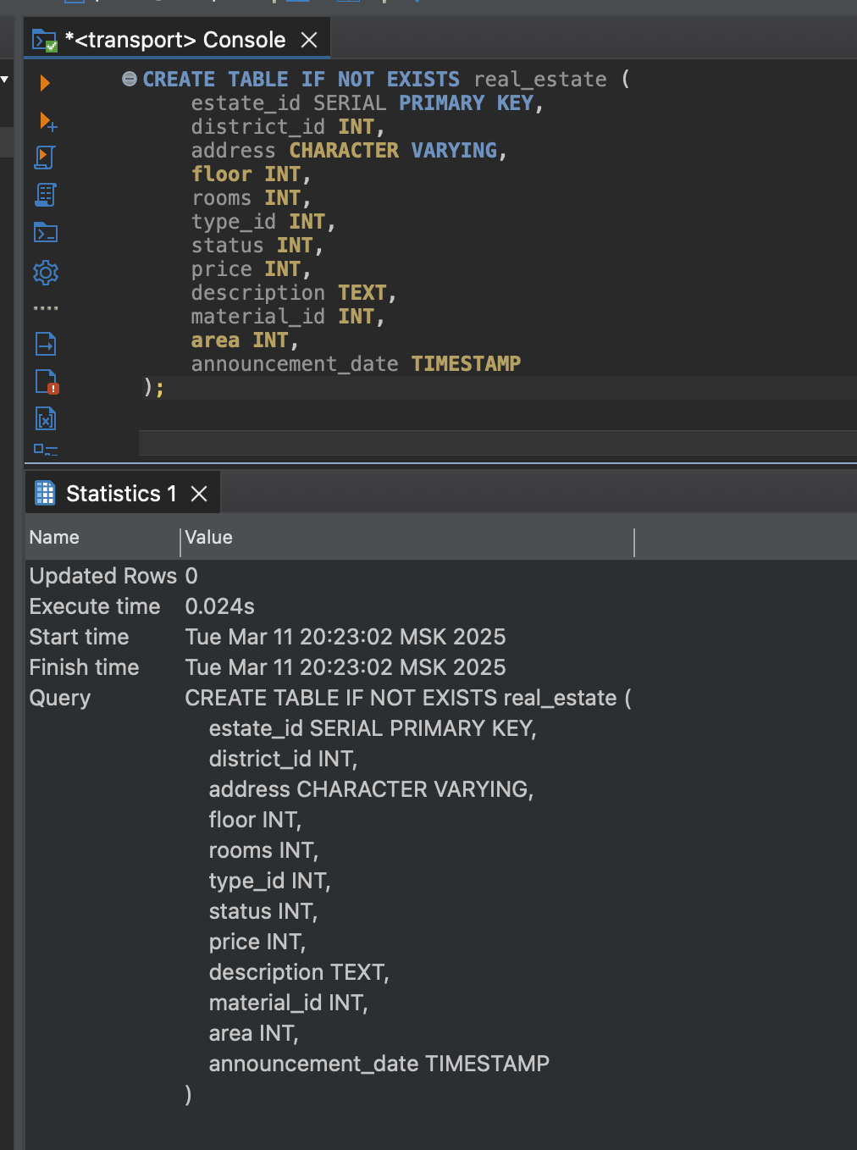
CREATE TABLE IF NOT EXISTS evaluation_criteria (
criterion_id SERIAL PRIMARY KEY,
criterion_name CHARACTER VARYING
);

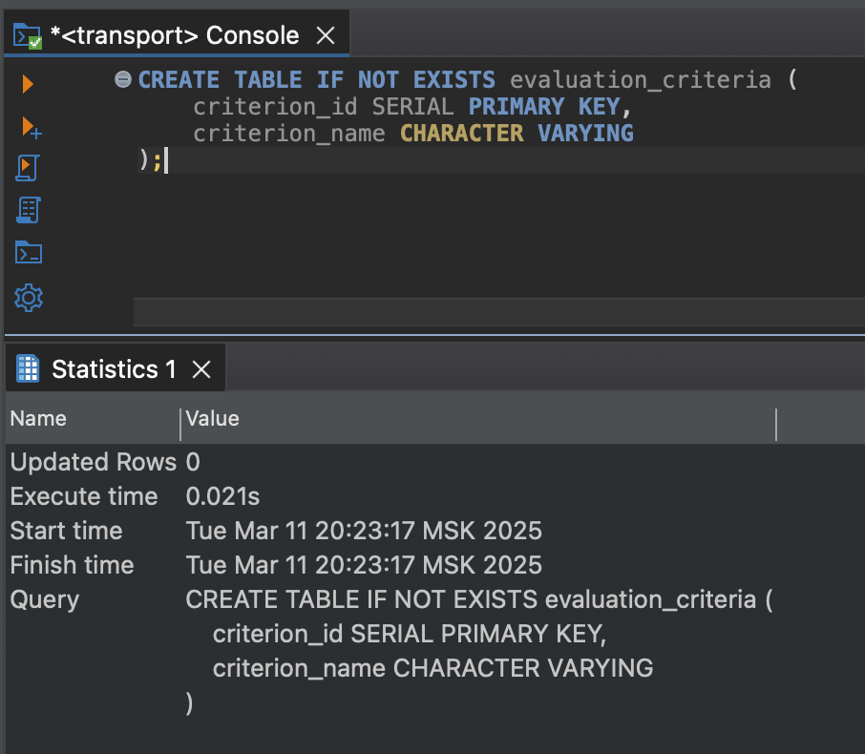

CREATE TABLE IF NOT EXISTS evaluations (
evaluation_id SERIAL PRIMARY KEY,
estate_id INT,
evaluation_date TIMESTAMP,
criterion_id INT,
evaluation_value DOUBLE PRECISION
);

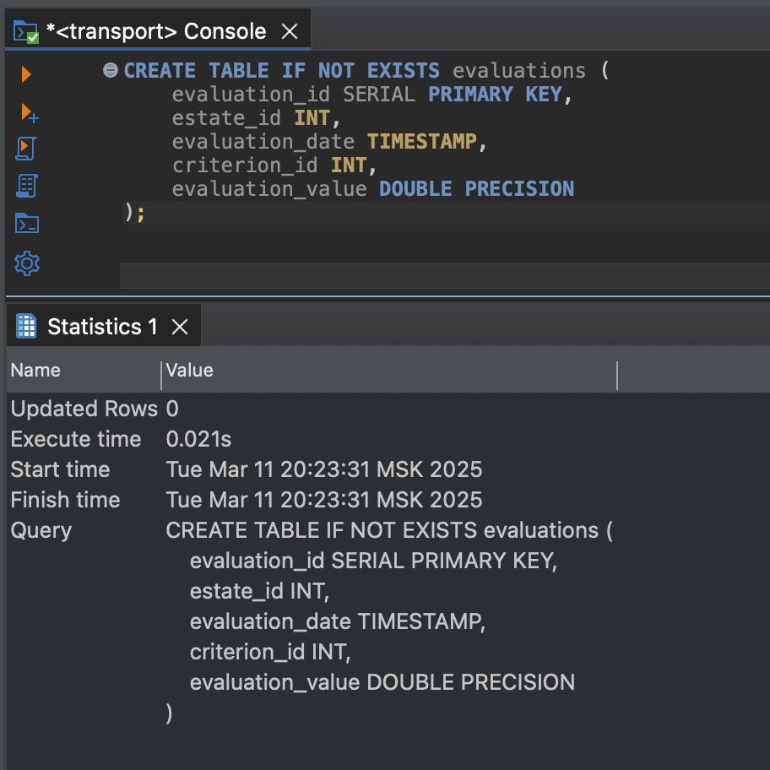

CREATE TABLE IF NOT EXISTS realtor (
realtor_id SERIAL PRIMARY KEY,
last_name CHARACTER VARYING,
first_name CHARACTER VARYING,
middle_name CHARACTER VARYING,
phone_number CHARACTER VARYING
);

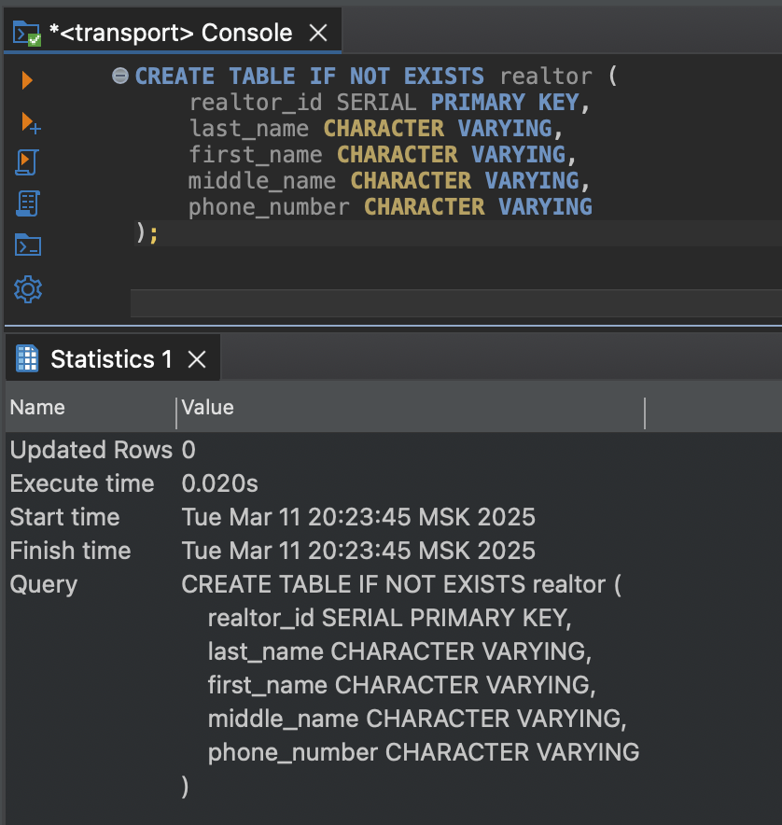

CREATE TABLE IF NOT EXISTS sale (
sale_id SERIAL PRIMARY KEY,
estate_id INT,
sale_date TIMESTAMP,
realtor_id INT,
sale_price DOUBLE PRECISION
);

